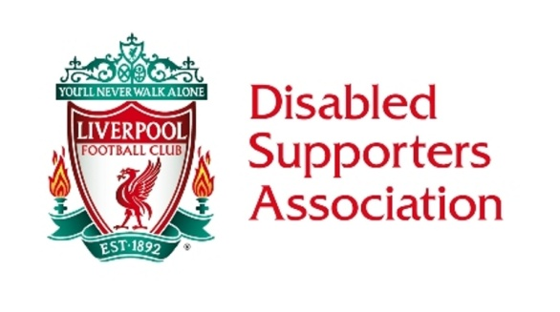
Friday 6 April 2018.
General Meeting 1pm KD Stand

Present: David Higham Laura Higham Samantha Mellor Steve Evans Ian Littlewood Kay Lindsey Leigh Hawksworth

1 Welcome & Apologies Tommy Hutchinson, Phil Lea, Simon Thornton
2 Matters Arising from the March meeting nothing to report back
3 Ticketing Update Season Ticket renewals going ahead online . Membership renewals will follow soon. The criteria for the carers concession will be set at the Enhanced rate PIP.
4 EIA Update ST away
5 Chair Update Constitutional changes. This will include the number of committee seats, an increase to 12 (including that of LFC rep) and the inclusion of an AGM. The new Constitution will be made available at the LDSA Forum on Thursday 12 April. Members can request a copy to be sent out in the post to them or within an email.
6 LDSA Forum Plans Tony Barrett, Head of Club and Supporter Liaison will be the guest speaker at the forum. 28 members have registered to attend plus the Committee members. There is a change from the buffet in previous years due to cost, but refreshments with cookies will be available. The agenda for the evening will go out and members unable to attend will be invited to put written questions to the guest and the Committee.
7 Premier League Advisory Group Report A draft of an away visit questionnaire has been given to the Committee for perusal and feedback.
8 Funding Update This months report is available from the Treasurer.
9 Members Update Currently on 229 members and application forms are still coming in.
10 Committee role descriptions Next meeting
11 Media & podcast Update Next Meeting
12 AOB LPF cost of recent NW Forum was £400, usually paid by the host club SE to keep the committee updated. The End of Season Supper is confirmed as 24 May, PL to update us on the Special Guest. An increase in the cost of meals from LFC have risen and thus the price of the tickets have been priced in line with this. New prices : £30 for a member and 1st guest, a second and subsequent guests will be £35. Additional children's meals are available on request at £10 . As in the past, KL to have the tickets printed. Regarding the appointment of a new President, it was agreed that we could have a joint Presidency of Margaret Aspinall & Sue Roberts. SM to contact and formally invite them.

13 Date of Next Meeting: 4 May, 1pm, KD Stand

