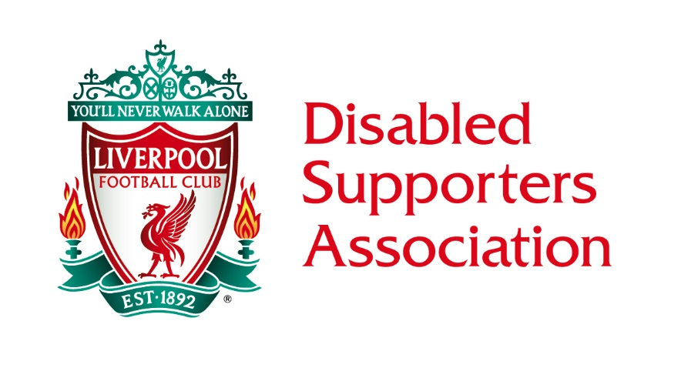
LIVERPOOL DISABLED SUPPORTERS ASSOCIATION
COMMITTEE MEETING MINUTES
FRIDAY 4TH JANUARY 2019 1PM

COMMITTEE ATTENDING
Pat Baxter, Steve Evans (Secretary), David Higham (Chairman), Laura Higham, Tom Hutchinson (Vice-Chair), Graham Lewis, Karl Lindsay, Kay Lindsay, Ian Littlewood & Samantha Mellor.
LFC STAFF & OTHERS ATTENDING
Leigh Hawksworth (Ticketing), Sonia Knight (PA to Simon Smith), Simon Smith (Head of Stadium Operations) & Simon Thornton (Diversity & Inclusion Manager).
APOLOGIES
Dave Hornblow.
WELCOME
The Chair welcomed everyone, and the meeting was opened at 13.05 hours.
MATTERS ARISING & RATIFICATION OF MINUTES
- The minutes from the December meeting were read and seen as a true copy and are now on the LDSA page of LFC’s website.
DIVERSITY & INCLUSION MANAGER (DIM) & STADIUM OPERATIONS
- The Disabled Supporter Experience is ongoing. Consultation with the LDSA will happen in due course.
- No update was able to be given on the Stanley Park car park egress issues. However, at the last two games it has been noticeably better. Also noted is that the traffic backing up on Walton Lane does cause a back-up to Priory Lane, and little can be done about this, apart from a filter lane to allow traffic access to go left, which will ease the overall congestion somewhat. This will be monitored over the remainder of the season.
- The unlevel walkway near to the portable toilets from the car park to Anfield Road has now been repaired.
- Feedback from the recent LDSA Forum was brought to the meeting by the DIM but is very extensive. Therefore, the Chairman and Committee will study the content and circulate to the relevant members as soon as possible.
- Two issues were raised from level 6 of the Main Stand. One is a safety issue with an unsecured gate, and the other, an issue with a Carer/PA accompanying the disabled member to the toilet in case of emergency. The DIM will investigate this further. In the interim or in case of uncertainty, supporters should approach a Head Steward for clarification and reporting of issues.
- The DIM was asked to discover and feedback if there is a go-to system or person to contact LDSA disabled members for their inclusion in events organised by the club or players.
- Can some form of seating be made available in the free-standing Kop Bar? There is currently no provision for ambulant supporters who require a seat if this bar is to be inclusive. The DIM will follow up on this.
TICKETING
- Tickets are now on sale for the Bayern Munich game. Payments are now being taken for auto-cup members. All selling details are on the club website Accessibility page. Members are encouraged to check the website regularly, as tickets for wheelchair bays and ambulant seats do become available for general and local sale.
- A question was asked about season tickets once again, and the feasibility of refunds as there is no disabled season ticket list. This is very unlikely to happen and if a supporter has issue, they can contact the Ticket Office direct via email or telephone. Likewise, with ambulant seating, online sales for disabled and the new telephone system due soon.

CHAIRMAN’S THANK YOU MESSAGE ON BEHALF OF THE COMMITTEE
- The Chairman offered a vote of thanks from the Committee to all the LFC staff involved in helping the LDSA resolve some critical issues over the last few months. A similar thank you was offered to those staff who helped make Mo Salah’s visit to the Christmas Party a pleasurable experience.
FUNDING & NEW TREASURER
- The new Treasurer will be Pat Baxter as proposed by Karl Lindsay and seconded by Laura Higham. The majority voted in favour, there was one abstention. Pat will begin with immediate effect.
- The account is now in a healthy position, statements were provided for the Committee to peruse. Members are more than welcome to ask for sight of the account balance.

CHAIR’S VISION 2019
- The sub-groups and points raised from previous meetings were disseminated by the Chairman. He alluded to the need to action these over the next few months and tasked each group with bringing results to the table.
- Level Playing Field will hold their Weeks of Action from Sunday 2nd to Sunday 17th March 2019. The Secretary and Social Secretary discussed possible ideas of how we should approach this, be it as part of a sporting activity day or other event. If anybody has any radical ideas, please share as soon as possible with the both Steve and Kay.
SUB-GROUPS
- A discussion was had about specific subjects for each group to be brought back and actioned at the February meeting. The proposed new website link will be sent to all Committee members today for agreement or comments within the next 48 hours.
- The Admin sub-group (Ian, Pat, Steve & Laura) will discuss a review of the minutes and use of EasyRead, Treasurer actions and Forum feedback.
- The Membership sub-group (Kay, Tom & Graham) will discuss events, tours and possible visits to Melwood, visiting fans, parking, satellite buses, carer criteria ID and badges or lanyards, including Committee visibility at games.
- The Development sub-group (Dave, Karl & Samantha) will discuss the new website, an LDSA video, a future magazine and grants.
AOB
- Nothing to report.
The meeting closed at 16.10 hours.
DATE OF NEXT MEETING
Friday 1st February 2019 at 1pm. The relevant lounge has been booked in the Kenny Dalglish Stand.
If members have queries or comments about these minutes, please feel free to contact us by E-mailing LDSA@liverpoolfc.com or on our LDSA telephone number 07592 839 931. The Secretary will attempt to respond to all enquires as soon as possible.

