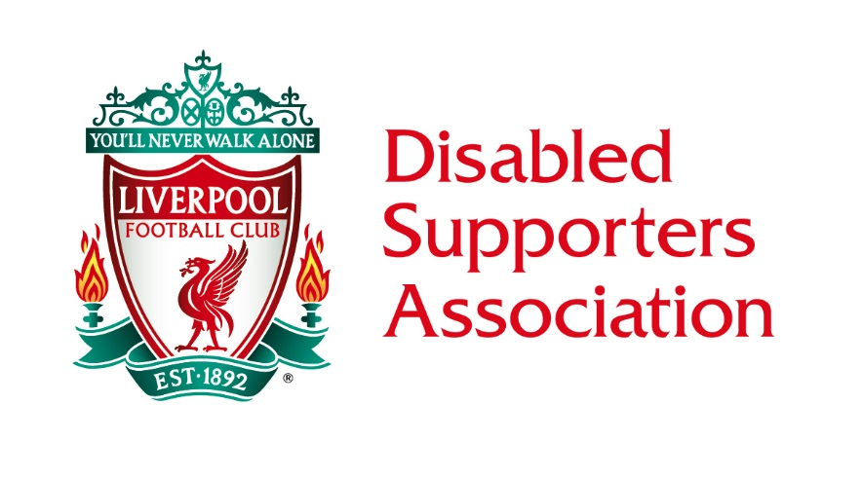
LIVERPOOL DISABLED SUPPORTERS ASSOCIATION
COMMITTEE MEETING MINUTES
FRIDAY 6th JULY 2018 1.00PM

COMMITTEE ATTENDING
Steve Evans, David Higham, Laura Higham, Tommy Hutchinson, Phil Lea, Karl Lindsay (P.A. to KL), Kay Lindsay, Ian Littlewood & Samantha Mellor.
LFC STAFF & OTHERS ATTENDING
Leigh Hawksworth (Ticketing), Simon Smith (Head of Stadium & Operations).
APOLOGIES
Simon Thornton (DIM) & John Morris (Stadium Foreman).
WELCOME
The Chairman welcomed all, and the meeting started at 13.14 hours due to late arrivals. Therefore, as Simon Smith was unable to stay, he gave a brief update about his team and how they hope to support us further by providing a representative at every meeting.
MATTERS ARISING & RATIFICATION OF MINUTES
- The minutes were ratified and are now on the LDSA page of LFC’s website.
DIVERSITY & INCLUSION MANAGER (DIM)
- No update available due to absence and apologies.

TICKETING
- Torino and Blackburn tickets are still available by telephoning the Ticket Office.
- WHU and American tour tickets available from Saturday 14th July.
- Bulk ticket sales for the first half of the season go on sale online for wheelchair members on Friday 13th July, and for ambulant supporters on Monday 16th July. There are no window sales and the online trial has been rolled out after a successful trial period.
- The Committee gave a vote of thanks for the hard work put in by all members of the Ticket Office.
- Registration for parking at home games can be done by members – after purchasing and confirmation of tickets, by emailing the Ticket Office on disability@liverpoolfc.com. There are a number of extra bays (55) hoping to be ready in time for start of the new season.
- Any photos of ‘illegal’ parking in disabled bays can be forwarded to LH in the Ticket Office. The Social Secretary was asked to forward any to the Head of Operations also.
CHAIRMAN’S UPDATE
- A discussion was had with regard increasing the Committee number by a further 1 member (the 12th man). This, since the club DIM is not seen as a full member of the Committee. This vote was carried.
- The Committee structure was discussed at length with the forming of 3 focus or sub-committee groups to enhance the overall efficiency of the Committee. It was felt that with the increase in Committee numbers happening from September, this would be a step forward. Initially on a trial period, and to be extended to a permanent fixture if seen as a success as we enter 2019. All voted in favour of this.
- The new Committee member applications were discussed, if required the necessary voting forms will be posted out after the cut-off date of 10th July 2018.
TREASURER
- An update was given on expenditure and receipts for the recent function.
- A balance was shown to the members present.
MEMBERSHIP
- The Membership Secretary confirmed we now have 234 members to date with at least 10 new applications awaiting processing for the start of the new membership year.
SOCIAL UPDATE
- The Jamie Carragher event was a great success, apart from some confusion over ticket allocation and refunds. This was discussed and actions taken to prevent a reoccurrence.

DEVELOPMENT & FUNDRAISING UPDATE
- Ladies Day that was scheduled for 28th July is now cancelled due to lack of ticket sales.
AOB
- The LDSA had received a voting proforma for Level Playing Field (LPF) dissolution of the charity and forming of a new company into an incorporated charity. The Chairman voted on behalf of the LDSA.
DATE OF NEXT MEETING
Friday 10th August 2018. The relevant lounge has been booked in the Kenny Dalglish Stand.
If members have queries or comments about these minutes, please feel free to contact us by E-mailing LDSA@liverpoolfc.com or on our LDSA telephone number 07592 839 931. The Secretary will attempt to respond to all enquires as soon as possible.

